Project Design Phase
India's Agricultural Crop Production Analysis
Project Title | India's Agricultural Crop Production Analysis
Domain | Agriculture / Data Analytics & Business Intelligence
Tool | Tableau Desktop / Tableau Public
Dataset | Historical Indian Crop Production Data, 1997–2021
Prepared By | Divya Kauluri (Team Project — completed individually; the team lead and other assigned members did not contribute to the work)
Mentor | [Not yet assigned / add name]
GitHub Repository | https://github.com/divyakauluri-spec/India-s-agricultural-crop-production-analysis
Tableau Public Link | https://public.tableau.com/app/profile/divya.kauluri/viz/IndiaAgricultureanalysisproject
Date | 02/07/2026

3.1 Problem–Solution Fit

Problem (User Pain) | Solution (Dashboard Feature)
Rajesh cannot decide which crops to grow each season without historical data | Top 10 Crops bar chart + Season-wise Production bar chart with state and season filters on Farmer Dashboard
Ananya cannot identify low-yield states without a geographic view of production | State-wise Production filled map on Policy Analyst Dashboard, filterable by season and year
Ananya cannot track long-term production trends without a time-series view | Year-wise Production Trend line chart (1997–2021) on Policy Analyst Dashboard
Vikram cannot compare crop production volumes to identify investment opportunities | Crop-wise Treemap + Top 10 Crops bar chart on Investor Dashboard
All users need a guided narrative to understand the full analysis | Tableau Story with 3 story points, one per persona, with descriptive captions
Users need access without installing Tableau software | Published to Tableau Public — accessible from any browser via URL

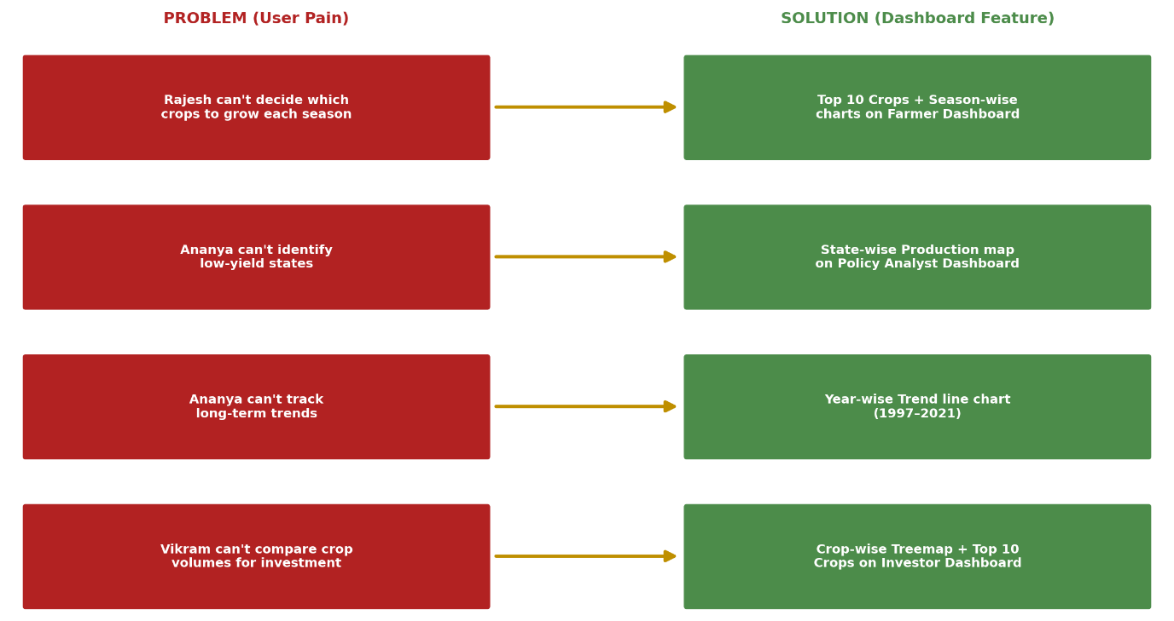
Figure 3.1 — Problem → Solution Fit Map

Reading the Fit Map

Every row in the Problem→Solution map is a direct pairing: an unfilterable government report becomes an interactive dashboard, a single national average becomes a state-level filled map, and a static spreadsheet becomes a shareable Tableau Public link with no login required. This one-to-one mapping is what kept the later design decisions in Sections 3.2 and 3.3 grounded in an actual user pain rather than a feature added for its own sake.

3.2 Proposed Solution
Problem Statement | India's agricultural stakeholders — farmers, policy analysts, and investors — lack a unified, interactive visual analytics tool to explore 20+ years of crop production data by state, season, crop type, and year. This leads to suboptimal farming decisions, ineffective policy targeting, and higher investment risk.
Idea / Solution Description | An interactive Tableau-based BI dashboard solution that transforms raw government crop production data (1997–2021) into five visualizations (filled map, line chart, bar charts, treemap) combined into three role-specific dashboards and a Tableau Story, published on Tableau Public for free browser access.
Novelty / Uniqueness | Role-specific dashboards tailored to three distinct user personas (farmer, policy analyst, investor) rather than a single generic view. The use of a Tableau Story adds a narrative dimension that guides non-technical users through complex data. The Yield = Production/Area calculated field adds an analytical layer not present in the raw dataset.
Social Impact / Customer Satisfaction | Farmers gain data-driven crop selection guidance, reducing income risk. Policy makers gain visibility into low-yield regions, enabling better resource allocation. Investors gain a clear view of high-growth agricultural sectors, reducing investment risk. The free Tableau Public deployment ensures accessibility without cost barriers.
Business Model | This is an individual capstone academic project delivered as a public Tableau dashboard. Future commercial potential: a paid subscription analytics platform for agribusiness firms, or a government-contracted BI solution for state agricultural departments.
Scalability | The solution is scalable — new years of data can be appended to the CSV source and the workbook refreshed. Additional crop types, states, or KPIs (e.g., rainfall, MSP prices) can be added as new calculated fields or data blends without redesigning the dashboard architecture.

The novelty and scalability points above directly inform the seven-layer architecture that follows: because the pipeline separates data cleaning (Layer 2) from visualization (Layer 4), new years of data, new calculated fields, or new KPIs like rainfall and MSP can be introduced without redesigning any dashboard downstream.

3.3 Solution Architecture
The end-to-end architecture for this project follows a linear BI pipeline from raw data to published dashboard:
- Layer 1 — Data Source: Raw Excel/CSV dataset (India Crop Production 1997–2021, 345,407 records, 10 original columns including State, District, Crop, Year, Season, Area, Production)

- Layer 2 — Data Preprocessing: Python (Pandas) script applied to rename columns to Tableau-friendly names, strip whitespace from Season/State fields, extract 4-digit numeric year from 'YYYY-YY' format into Crop_Year_Numeric column, add Yield = Production/Area calculated column, output as skillwallet_crop_cleaned.csv (12 columns, 345,407 rows, zero nulls)

- Layer 3 — Tableau Data Connection: CSV connected as Text File in Tableau Public; State_Name field assigned Geographic Role = State/Province for map rendering; Crop_Year_Numeric used as continuous dimension for time-series axis

- Layer 4 — Visualization Layer: 5 individual worksheet charts — (1) State-wise Production filled map, (2) Year-wise Production Trend line chart, (3) Top 10 Crops by Production bar chart, (4) Season-wise Production bar chart, (5) Crop-wise Treemap excluding Coconut outlier

- Layer 5 — Dashboard Layer: 3 role-specific Tableau dashboards — Farmer Dashboard (charts 3+4), Policy Analyst Dashboard (charts 1+2 with Season/Year filters), Investor Dashboard (charts 3+5)

- Layer 6 — Story Layer: Tableau Story with 3 story points, each embedding one dashboard with a narrative caption for the respective persona

- Layer 7 — Publishing & Delivery: Workbook saved to Tableau Public via File → Save to Tableau Public; shareable URL generated and submitted to the GitHub repository
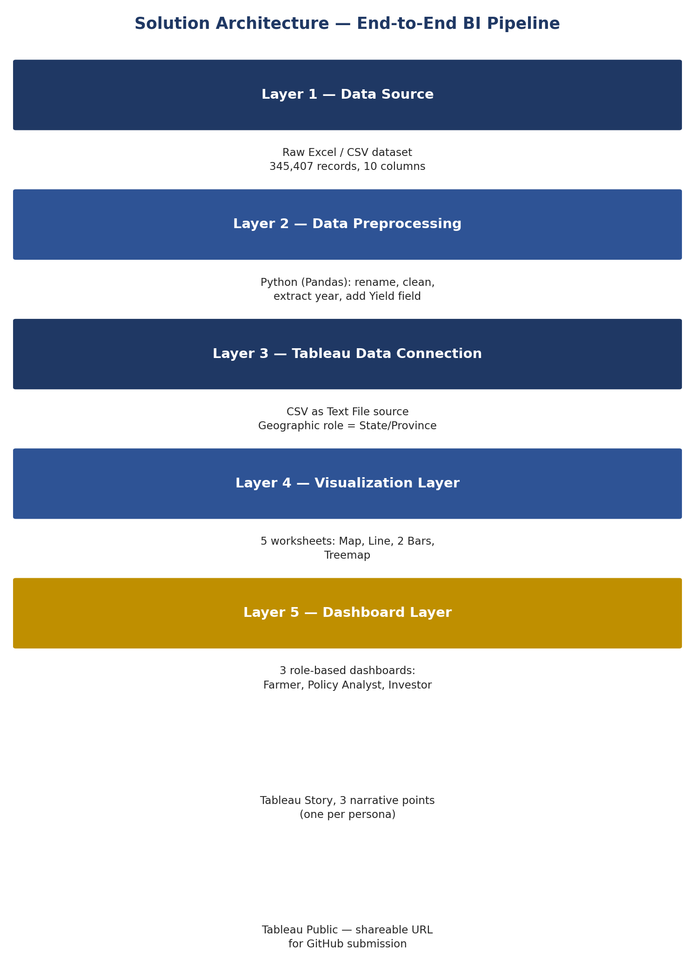
Figure 3.2 — Solution Architecture (7-Layer BI Pipeline)

